Simulations

Abstract
This document records the simulations conducted for the project, including the following parts:
- System Overview
- Filter Simulation
- Rectification Simulation
- Motor Simulation
- PWM Generation
- Motor Simulation with user-defined function

Several simulations have been conducted through Simulink including filter simulation, rectification simulation and motor simulation. All simulations were carried on with a sample time of 10 microseconds and using ODE3 as a solver.

System Overview
The system has been constructed as shown. The inverter system controls a 2KW induction motor whose torque characteristic is currently unknown. The currents flowing into the inductor motor are used as feedbacks to the PWM function which is to be written in the following semester.
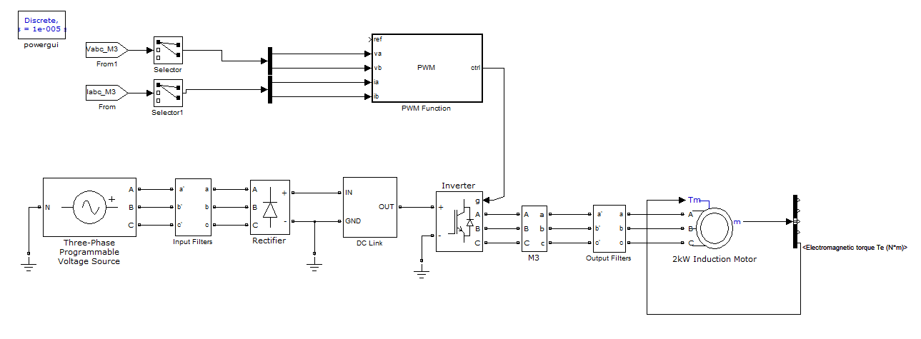

Figure 1. An overview schematic of the inverter system

Filter Simulation
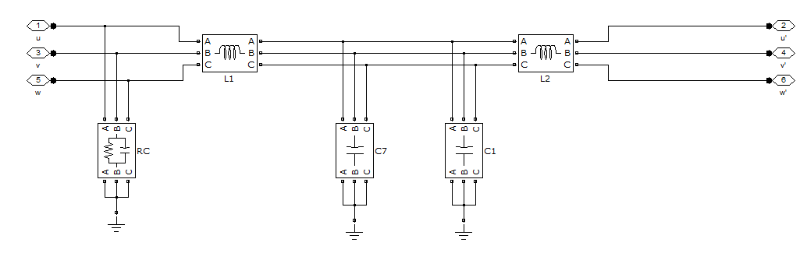
The EMC filter is placed between the mains and the rectifier. The mains are configured to contain possible harmonics and noises.

Figure 2. Schematic of the EMC filter

The values of the components used are in accord with those in the EMC filter from EMHeater.

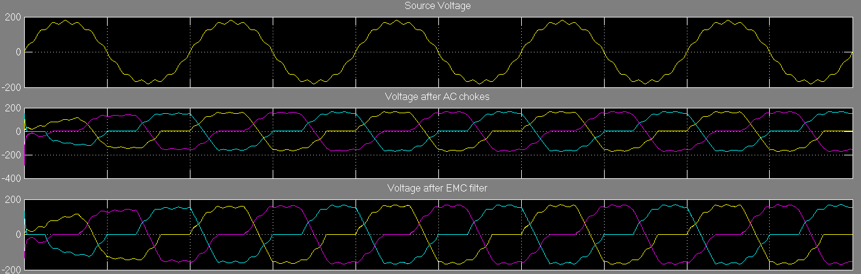

Figure 3. Simulation result of the EMC filter

It can be seen from the result that the harmonics has been reduced while it introduces a flat region to the waveform. Further investigation reveals that the problem arises from the AC choke filter whose inductance value is currently unknown.

Rectification Simulation
The rectification schematic also includes the DC-link section which contains a inductor in parralel with a large storage capacitor. The rectifier is constructed with six diodes with snubber capacitance. The source remains the same as above.
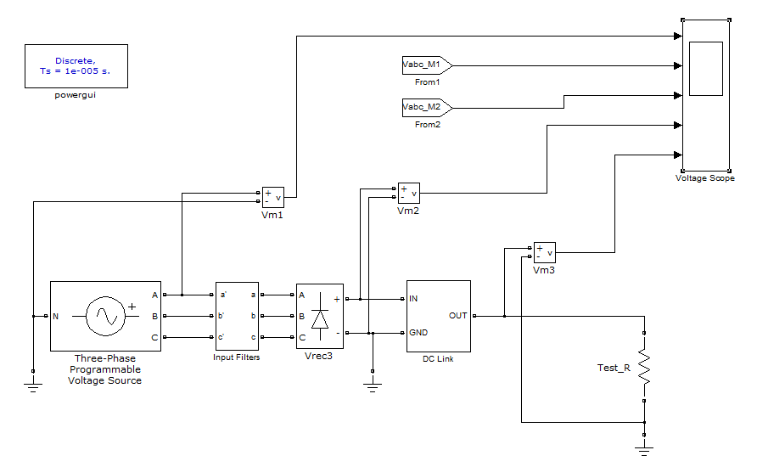

Figure 4. Schematic of the rectification section

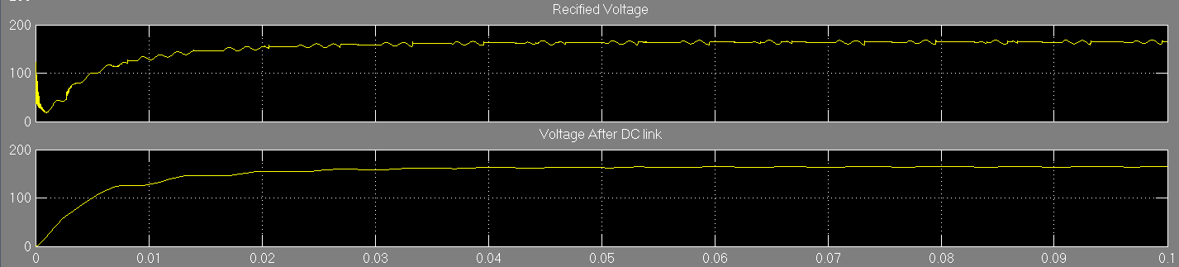

Figure 5. Simulation result of the rectification section

It is observed that the stabilized output of the rectifier contains mainly DC with moderate distortions which are further reduced by DC-link. The voltage after DC link is almost DC with a voltage of 157V

PWM Generation
Pulse width modulation (PWM) can be generated using two different methods. The first one makes use of triangular wave with which reference signals are compared whereas the second method utilizes the principle of PWM.

The first method, triangular wave method, is often used to physically generate PWM with electrical elements.
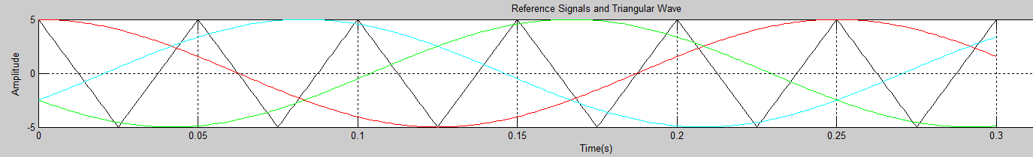

Figure X. Reference signals and triangular wave

In this case, the triangular wave is simulated with the code
tri_wav= (2*amp/(tri_per/2))*abs(mod(t,tri_per)-tri_per/2)-amp;
where tri_per is the period of the triangular wave and amp is the amplitude.
Then, reference signals are compared with the triangular wave in such a way that if the reference signal is larger, the PWM control signal becomes 1; otherwise, 0. The PWM control signals are pair-wised signals in that the PWM for the upper switch in one leg is equivalent to the PWM for the lower switch in the same leg.
The PWM signals for one reference signal are shown in Figure X below.
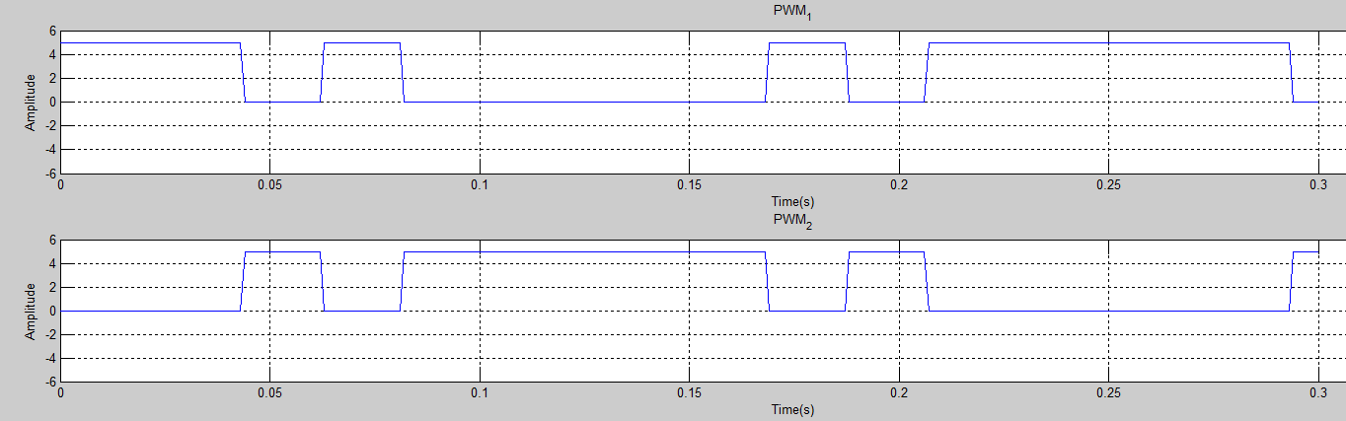

Figure X. PWM1 and PWM2 generated using triangular wave method

The second method uses the principle of PWM which states the average value of the waveform can be approximated by
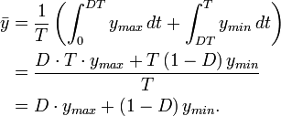

where D is called the duty cycle and is given by
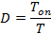

In our case, y_{min} is zero, so the formula can be simplified to
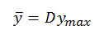

We can obtain y from the reference signal with a period of T. If y is known, we can easily calculate D and Ton. The PWM can thus be generated with Tons in a way that in a period of T, the signal is set for Ton.
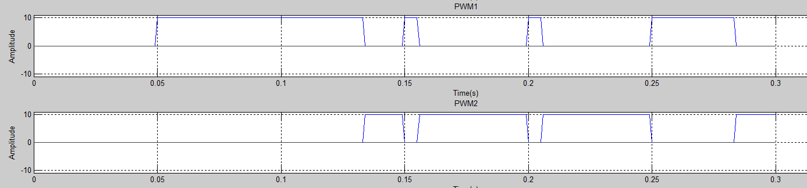

Figure X. PWM1 and PWM2 generated using principle method

Motor Simulation
The motor simulation assumes the input of the inverter to be a well-rectified DC, which is modeled by a DC source. The three-pahse PWM generator is set to generate a 50Hz modulation signal feeding into the inverter. The torque is fed back to the induction motor with a torque-speed characteristic as shown.
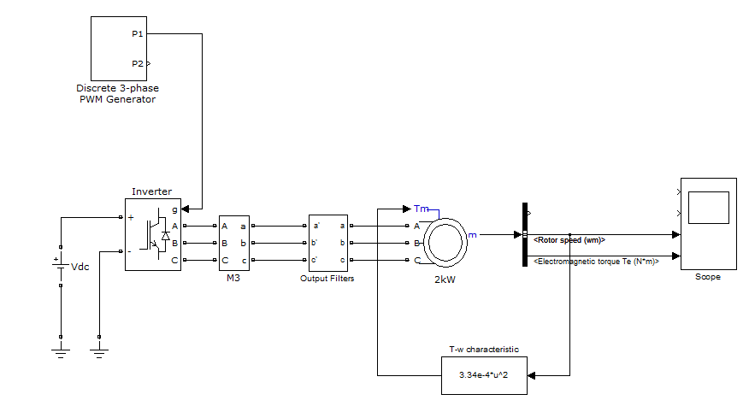

Figure 6. Schematic of 2KW induction motor

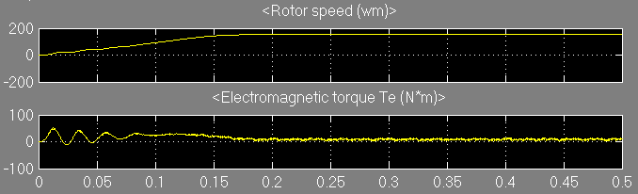

Figure 7. Simulation result of 2KW induction motor

It can be observed that the rotor speed is constant after 0.18s whilst the electromagnetic torque stabilizes after the same period of time.

Motor Simulation with user-defined function
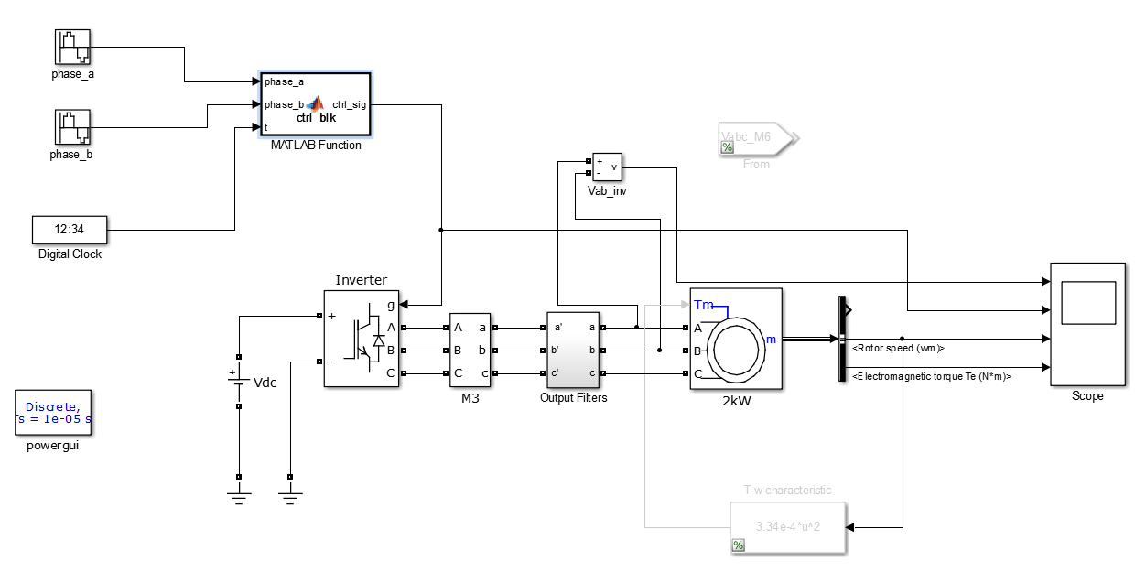

Figure 8. Schematic of 2KW induction motor, with user-defined function

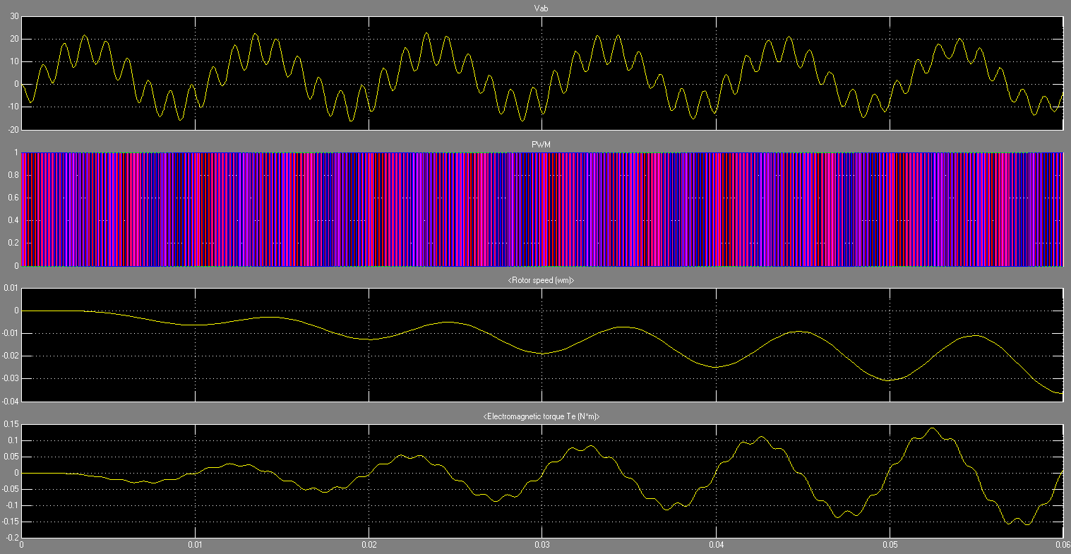

Figure 9. Simulation result of 2KW induction motor, with user-defined function

The ripples can be reduced with appropriate filters.

Delay

The universal bridge model is configured to have switching delays. The fall time and tail time is set to 1 us, which is greater than most commercial IGBTs.

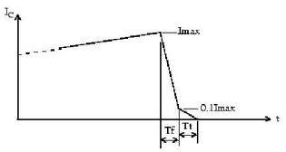

Figure 1 IGBT Fall time and Tail Time ^{[1]}

Reference
[1] S. Fagerstrom, N. Bengiamin, MATLAB - A Fundamental Tool for Scientific Computing and Engineering Applications, 2012

